Sprint 2 Plan
“Opportunity Posting & Feed”

SlugIn

Aashna Shimkhada, Christina Chan, Erika Wu, Jetha Mot, Sara Srivastava, Sharon Akkara
Sprint Completion Date: November 4th, 2025
Revision 1: October 23th, 2025
Goal: To allow faculty and student leaders to post opportunities. To allow students to access and view these opportunities in a feed, save opportunities, and mark opportunities as applied.
Task listing, organized by user story:
User Story 2.1: (“As a student, I want to mark an opportunity as applied for once I have filled out the application linked to the opportunity or emailed the professor listed on the opportunity.”) (7 points)
- Task 1: Add a “Mark Applied” button to each opportunity posted on the opportunities page (1)
  - Authenticate that this button is only visible to logged in users (2)
- Task 2: Add the functionality to the apply button
  - Update application status on Supabase (3)
  - Update “Mark Applied” button to display “Applied” (1)

User Story 2.2: (“As a faculty member or student club, I want to make job postings and categorize the jobs (Ex: Humanities, Computer Science, etc.) so that I can recruit new members.”) (22 points)
- Task 1: Create a /post page path (1)
- Task 2: Code input fields mentioned in design for opportunities page (5)
  - Title (text input)
  - Description (text input)
  - Deadline/Expiry date (date picker)
  - Location (text input)
  - Optional file upload for flyer/picture
- Task 3: Add 1 box for post tagging (categories) (2)
  - Multi-Select Drop Down with all UCSC Majors (?)
  - User-Input separated by commas (EX: comp sci, comp eng, biotech) (?)
- Task 4: Add “Post Opportunity” button (1)
- Task 5: Update Posts/Opportunities Database with user input on button click (3)
  - On button click, capture the user input and selection and execute a backend call

- Task 6: Create a /opportunities page path (1)
- Task 7: Create post/opportunity card (4)
  - Quick view: for scrolling on the feed
  - Full View: user clicks on card
- Task 8: Create opportunity feed page (2)
  - Layout for user to scroll through opportunity cards
- Task 9: Connect backend/database to populate feed page with opportunity cards (3)

User Story 2.3: (“As a faculty member, I want to be able to see the number of saves and applications so I can see how well my posting is doing.”) (11 points)
- Task 1: Create a /myopportunities page path to show posted opportunities (1)
- Task 2: Prepare the backend for viewing post metrics
  - Configure backend to keep track of application count per opportunity (ex: applicationCount) (1)
  - Include authentication that only the logged in user can view their posted opportunities (2)
- Task 3: Display the opportunity(s) posted by the user and the fetched data on number of saves (ex: Applied: X) (3)
- Task 4: Implement periodic updates
  - Add a “Refresh” button to the myopportunities page (1)
  - Fetch the data from Supabase (2)
  - Include a timestamp of last refresh (1)

Team roles:
Aashna Shimkhada - Developer
Christina Chan - Product Owner, Developer
Erika Wu - Scrum Master
Jetha Mot - Developer
Sara Srivastava - Developer
Sharon Akkara - Developer

Initial task assignment:
Aashna Shimkhada - US 2.1 Tasks 1-2
Christina Chan - US 2.1 Tasks 1-2
Erika Wu - US 2.2 Tasks 6-9
Jetha Mot - US 2.2 Tasks 1-5
Sara Srivastava - US 2.2 Tasks 6-9
Sharon Akkara - US 2.2 Tasks 1-5
Initial burnup chart: A graph giving the initial burnup chart for this sprint and is labeled as such with sprint number and project name and is located in the lab.
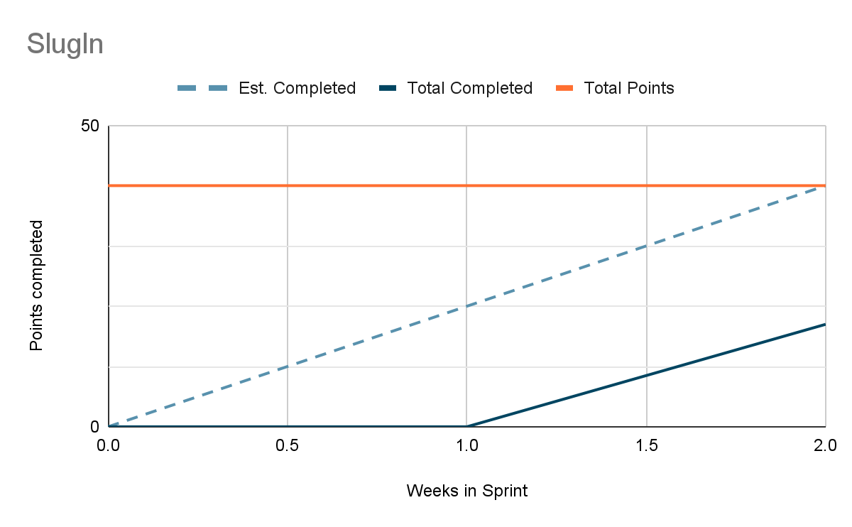
Initial scrum board: Also known as a task board, the scrum board is a physical board and labeled as such with sprint number and project name and located in the lab. This board has four columns, titled user stories, tasks not started, tasks in progress, and tasks completed. Index cards or post-it notes representing the user stories and the tasks for this sprint should be placed in the user stories, tasks not started, and tasks in progress columns. Tasks associated with a user story should be placed in the same row as the user story.

User story | Task | In progress | complete | Story points
User Story 2.1: (“As a student, I want to mark an opportunity as applied for once I have filled out the application linked to the opportunity or emailed the professor listed on the opportunity.”) | Task 1 |  | X - AS 11/2 | 3
 | Task 2 | X - AS 11/2 |  | 4
User Story 2.2: (“As a faculty member or student club, I want to make job postings and categorize the jobs (Ex: Humanities, Computer Science, etc.) so that I can recruit new members.”) | Task 1 |  | X - Jetha 11/2 | 1
 | Task 2 |  | X - Jetha 11/2 | 5
 | Task 3 |  | X - Jetha 11/2 | 2
 | Task 4 |  | X - Jetha 11/2 | 1
 | Task 5 |  |  | 3
 | Task 6 | X - Erika 10/29 | X - Erika 11/2 | 1
 | Task 7 | X - Erika 11/2  X - AS 11/2 |  | 4
 | Task 8 |  |  | 2
 | Task 9 |  |  | 3
User Story 2.3: (“As a faculty member, I want to be able to see the number of saves and applications so I can see how well my posting is doing.”) | Task 1 |  |  | 1
 | Task 2 |  |  | 3
 | Task 3 |  |  | 3
 | Task 4 |  |  | 4

Scrum times: List at least the three days and times during the week when your team will meet and conduct Scrum meetings. Also, indicate which of these meetings will have the TA/tutor visit as arranged with the TA/tutor. It is expected the TA/tutor will visit during the Scrum meeting during your lab time.

Times meeting:
- Saturday 1 pm - 2 pm
- Wednesday 9 am - 10 am
- Monday 9 am - 10 am
Meeting with TA:
- Wednesday 4:30 pm - 5:15 pm

